Software Requirements

Specification

for

Mars Project-Internship

Version 1.0



Last Revised on : 08/01/2019

Contents

1. **Introduction**
   1. Purpose
   2. Document Conventions
   3. Intended Audience and Reading Suggestions
   4. Project Scope
2. **Overall Description**
   1. Product Perspective
   2. Product Features
   3. User Classes and characteristics
   4. Operating Environment
   5. Design and Implementation Constrains
   6. User Documentation
   7. Assumptions and Dependencies
3. **System Features**
   1. **Login and Registrations**
      1. Description and Priority
      2. Stimulus and Response Sequence Registration
      3. Functional Requirements
   2. **Internships**
      1. Description and Priority
      2. Stimulus and Response Sequence Registration
      3. Functional Requirements
   3. **Companies**
      1. Description and Priority
      2. Stimulus and Response Sequence Registration
      3. Functional Requirements
   4. **Search**
      1. Description and Priority
      2. Stimulus and Response Sequence Registration
      3. Functional Requirements
   5. **Sending Message**
      1. Description and Priority
      2. Stimulus and Response Sequence Registration
      3. Functional Requirements
   6. **Internship Application Form**
      1. Description and Priority
      2. Stimulus and Response Sequence Registration
      3. Functional Requirements
4. **External Interfaces Requirements**
   1. User Interfaces
   2. Hardware Requirements
   3. System Requirements
   4. Communication Requirements
5. **Non-Functional Requirements**
6. **Appendix**
   1. ER Diagram
   2. Class Diagram
   3. Use Case Diagram
   4. Use Case Scenarios
7. **Development Team**

# Introduction

## Purpose

Universities in Sri Lanka (state, private, semi-gov.) expect and encourage the students to find an internship during their time of academic period. It is important to have some practical training in their field for their carrier. But finding an internship is not that easy. As the students of SLIIT; we know the hardness of this process very well. It tends to be difficult and inconvenient for students of SLIIT to find an internship at a company to gain their knowledge and skills which belong to the particular degree program (IT, Business studies, Engineering and Hospitality Management).

Even though there were some job-seeking websites such as, top jobs, Xpress jobs …; we have not found any single web site which helps to students to find the internships that they are required to do in their academic period. As a solution to this problem we implement a real time web site which helps the students to find the companies that fit with their own peculiarities and match with their academic requirements. Before select an intern; they have to think about the capacity of work they can do, the time period of internship they’re required and the field’s knowledge they should observe through the internship. This website provides the internships whenever they want but during their academic years.

## Document Conventions

* The Chicago referencing style is used for all references to outside sources.
* This SRS was prepared based on the SRS template layout obtained from Curtin University Blackboard website.
* This document has been created by using Microsoft Word 2016 and has been used Times New Roman font with fixed font size of 11.5pt and 1.5 line spacing.

## Intended Audience and Reading Suggestions

The intended audience for this system would be of three types:

* Students of Sri Lanka Institute of Information Technology.
* Academic members of Sri Lanka Institute of Information Technology.
* Companies which offer internships through our web sites.

The system will be useful for the first two parties to find appropriate internships and companies. Also will be useful for the last party to offer internships in order to recruit the best employees for their companies.

The intended audience for this document would be,

* Academic members of SLIIT.
* Team members who are dedicated to develop and implement this system.

## Project Scope

The system helps users to find the best internships that are offered by the companies in Sri Lanka. Students’ login details are validated and authenticated to check whether the student is a current studying student or not in SLIIT. From login details the system identifies the field that they’re studying and according to that; students are viewed top 10 internship companies which have been decided as the best companies available at the moment by the academic staff of SLIIT.

Students are able to view internships (including the top 10 internships) and search for the specific companies/job titles. There is an aptitude test (online quizzes / hyperlinks that redirects the student to the online quiz elsewhere) which is offered by the system and/or the company to get an idea of the average knowledge of the student. Score of the quiz is only visible for the selected company, SLIIT academics (Admins for each faculty heads preferably the Dean) and the developers of the web site.

# 2. Overall Description

# Product Perspective

The product is being covered in this SRS is a new and largely standalone product. The product contains are for the web clients who have been having a hard time on finding internships and the once who will be facing that in the future.

In order to reduce the problems and hardness students faced when handling the manual process of finding internships, this web site ensures the SLIIT students can successfully login into the website by using Courseweb credentials and be able to view all companies and internships which belong to their field. Any student cannot check, look or apply to another field internship even in whatever situation that he/she is in. But students are able to view all the positions available in each company under their field and can apply for any of them.

Students need to log in with SLIIT Courseweb credentials to use the features of this MAS web site.

## Product Features

Students who missed carrier guidance day needs to have zero worries. The goal of this product is to service SLIIT students with the motive of finding the ultimate internship whist giving the higher authority (admins) priority over the web site accordingly. Features of the system are discussed in depth in Chapter 3.

## User Classes and Characteristics

It is anticipated that the students of SLIIT would use the system for their needs, as it will resolve a lot of their issues on finding a perfect place / position as an intern, particular requirements that need to be covered by an undergraduate who needs to get an internship from a company and all internships are not classified and qualified as they expected. These kinds of problems between companies and undergraduates are driving our country into a global unemployment problem that we will face in the future. So we provide this real time solution to these undergraduates for their convenience. This website is implemented for students of SLIIT in order to allow selecting an internship at a given company under their field.

## Operating Environment

The web client will be available cross-platform for any operating system with a compatible web browser, with the latest versions being recommended in order to ensure full compatibility with the client. The web site is developed by using MEAN Stack development, Node.js and MongoDB servers (the web pages are provided by using Node.js, and additional data will be stored in a MongoDB database). SLIIT student database is used to verify the accuracy of entered login details by students. Validations and authentications are critical to ensure that the student is a current studying student in SLIIT.

The system should be user friendly and should achieve good user experiences along with good usability goals. Communications between databases are handled by the Node.js server.

## Design and Implementation Constraints

Due to some strict rules and regulations regarding to the SLIIT; we take the responsibility of the site security and the login details of the users to keep highly secured way. Additionally, since the system as a whole is being designed with only people studying at Sri Lanka Institute of Information Technology being the intended users, it will be of no use for students/ undergraduates/ any intern or job seekers outside of SLIIT. In order to maintain the durability and authenticity of the system, considerable number of design and implementation constraints are applied.

## User Documentation

The user manual, which is written in simple understandable language will be provided to admins of each faculty. It clearly describes the inner complexity of the system and guides the user throughout the process. A soft copy of the user manual will be delivered to the admins with the system. A FAQ (Frequently Asked Questions) will also be developed with a common set of questions and answers to be used by the users.

## Assumptions and Dependencies

It is assumed that the user has a basic considerable knowledge to use the web site.

1. System Features
   1. Login and Registration
      1. Description and Priority

This feature allows user to access the MARS web page by giving the SLIIT course web password and the student ID. System identifies the students who are following a hospitality degree and requests them to register with MSI website since they do not have a SLIIT course web login.

* + 1. Stimulus/Response Sequence

Registration

1. Registration process is only available for SLIIT students who are following a Hospitality degree (in the moment).
2. User has to select the sign up option and needs to enter the Student registration number along with a new password.
3. The system automatically verifies the accuracy of the provided details when the user presses the Register button.

(If valid, the user is registered in the database, otherwise an error message indicates that the invalid inputs have been provided to the system and the user is prompted to re-enter the valid data).

Login

1. User is required to enter the SLIIT registration ID along with the course web password.
2. The system checks accuracy of the provided login details by using SLIIT student database.

(If both are true, the user is logged in; otherwise the user is prompted to

Re-enter their username/password.)

* + 1. Functional Requirements

REQ-1: The user needs to support login sessions.

REQ-2: It must be possible to verify the data that entered during login/registration on the user’s end.

1. Internships
   * 1. Description and Priority

This feature allows user to select an intern type that they are looking for, according to their field of study. As an example it can be software developer, Business analysis, Civil engineering, Database analysis etc. Each internship type is contained a list of companies that a student can apply.

* + 1. Stimulus/Response Sequence

1. User needs to select the internship button and once button is pressed; system shows all the internship types available in our website.
2. Then user can select an internship type.
3. Once the user selects an internship type; system shows a list of companies which are related to the selected type and then student can apply for an internship according to his/her desire.

3.2.3 Functional Requirements

REQ-1: The student has to select the company

REQ-2: The student selects the designation along with the duration of the internship and will be able to apply for the internship through our website.

1. Companies

3.3.1 Description and Priority

This feature shows a list of company names that are available on our website. User can select a company and find an internship according to the field of they’re studying. In addition to that, system shows the top 10 company names on the top of the list and it will be helpful for the students when they select a company.

3.3.2 Stimulus/Response Sequence

1. User selects the button called “company” and it shows a list of company names that are available on our website.
2. User can select a company and find the available internships.
3. Apply for an internship if there is/are a vacant(s).

3.3.3 Functional Requirements

REQ-1: Companies will be retrieved by the MongoDB database

REQ-2: Maintenance team would handle the current companies in the system

3.4 Search

1. 3.4.1 Description and priority

Search function can be used to find a company name, internship or it can be used by the administration staff in order to search a particular students’ profile.

* + 1. Stimulus /Response Sequence

1. User can type a company name, an internship or a student name/ID on the search bar.
2. When the user types something on the search bar and presses the search button; System finds the relevant details and shows it to the user.
3. If user types something which is not available in our website, then system is prompted a message to the user saying, “No results found”.

3.4.3 Functional Requirements

REQ-1: Search by relevant keywords (Student name/Company name)

REQ-2: System displays the results in a list

* 1. Sending messages

1. Description and priority

By using this feature, user can contact MARS website’s administrators at any time if there is any clarification needed on our products. Any user can send us messages, calls or can find us from Google maps.

* + 1. Stimulus /Response Sequence

1. User needs to select the option called “send us messages”.
2. In order to send a message, user needs to fill the requesting form available on the website and needs to press send button.
3. If any user needs to contact us; users can click on the “contact us” button and get our contact number.
4. If any user wants to find our office, user can click on the “Find us” button and then system will provide the location through the Google map.

3.5.3 Functional Requirements

REQ-1: The user can send feedback by providing basic credentials (name, email)

REQ-2: The feedback should be notified to admins and maintenance team

* 1. Internship application form

1. Description and priority

In order to apply for an internship through this website, firstly student needs to fill the Internship application form. Student needs to fill all the fields required and cannot keep empty fields.

* + 1. Stimulus /Response Sequence

1. Select the Internship application form button.
2. Fill all the fields in the form.
3. Press the submit button.
4. If there were empty fields, system is prompted a message saying, “cannot keep empty fields”.
   * 1. Functional Requirements

REQ-1: Obtain student details and the internship details via a form

REQ-2: Send details of student to NodeJS server and store in database

4. External Interface Requirements

In this section, external interface requirements of the product are described under four main categories. Those are user interfaces, hardware interfaces, software interfaces and communication interfaces.

The main purpose of this section is identification and documentation of the interfaces and interaction of the system with external entities in detail.

4.1 User interfaces

The below screenshots may vary as they were taken as the outlines with the main purpose of explaining the concluded result in a clear manner.

Our system will be accessed by both administrators and the registered users.

Admins have the instinctive power to engage in the altering of all the interfaces of the system.

Admins are further divided as the admins of the developing side (MARS) and admins of the organization (SLIIT).

Admins of the organization are able to access all the student profiles and company details while all the information associated with students and companies are managed by the admins of MARS.

All the details mentioned in the site can be updated and edited by the admins and also, they have the access to the messages sent by students.

The figures 4.1.1 and 4.1.2 illustrate an interface which is visible to admins.

They can access the information related to internships and companies by clicking the buttons provided at the top of the interface.

Admins can edit the details relevant to the company and the system such as location, contact details and most important legal information through this interface.

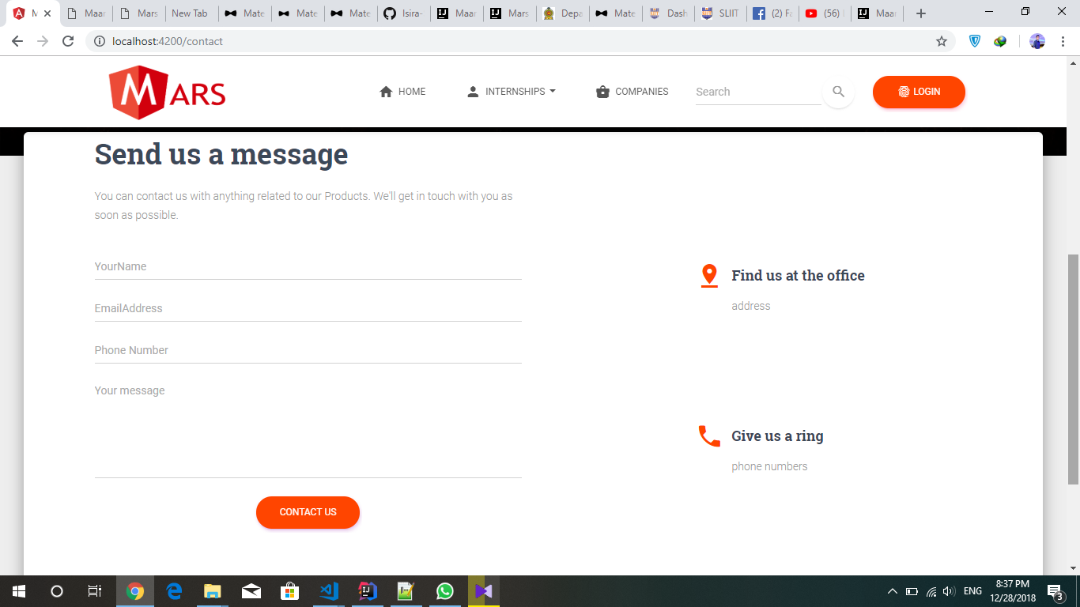

Figure 4.1.1

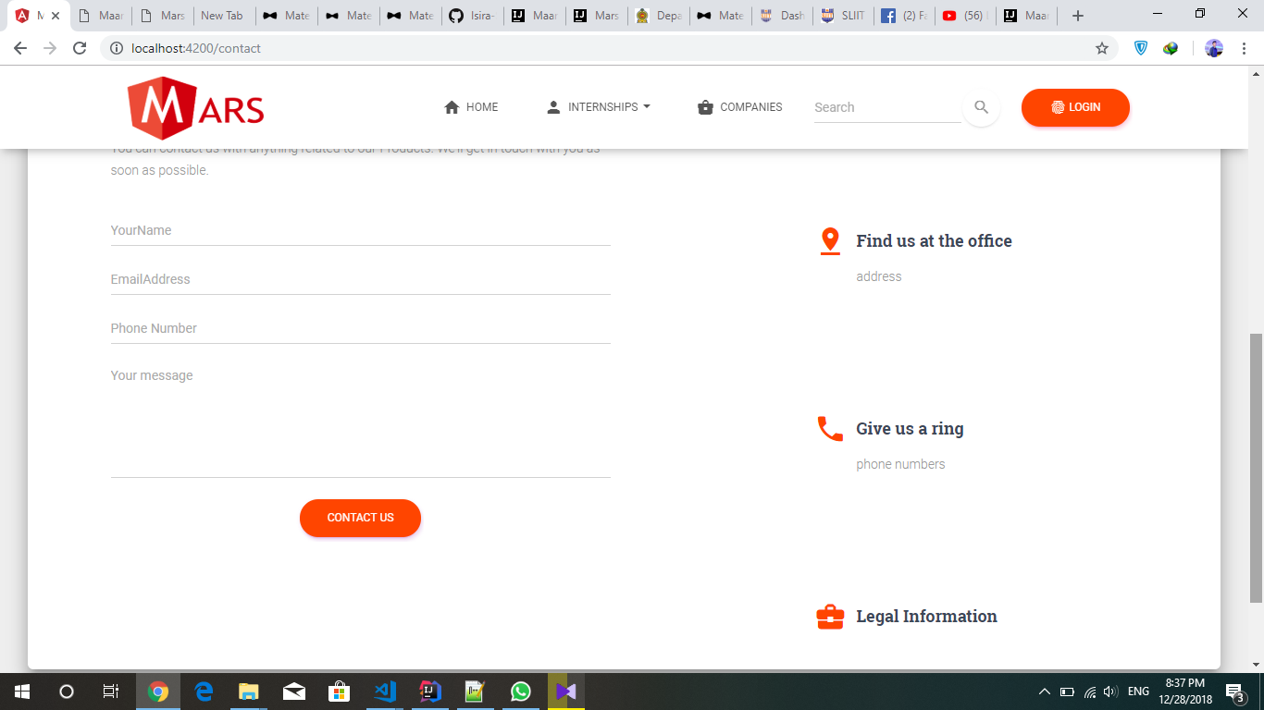

Figure 4.1.2

If the user is a student, he/she can log into the system using the credentials which are used to log into the Courseweb of SLIIT (Figure 4.1.3).

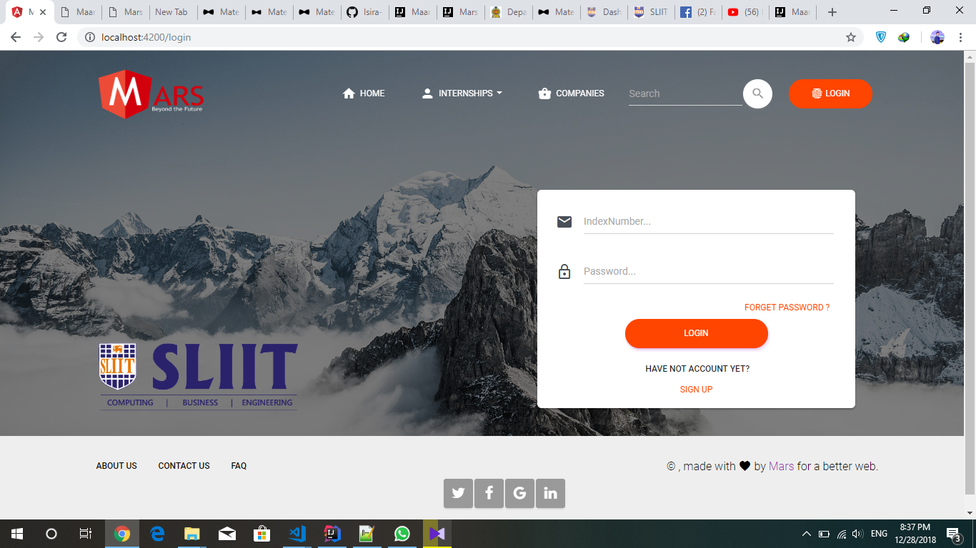

Figure 4.1.3

This interface consists of two compulsory fields named, “Student ID” and “Password”.

There are options like “SIGN UP” for the users who have not signed up yet and “FORGOTTEN PASSWORD” for the users who forgot the password.

If the login credentials are correct, main user interface of the system, which is “Home” will open up. Otherwise an error message will be displayed.

User can enter the search item he/she is looking for and the specifications he is interested in by clicking on “Search” where the system will end up providing the related list of items according to the searched keyword.

User can access the information related to internships and companies by clicking on the buttons available on the top of the interface where the most up to date internships and companies will be sorted down according to the profile details of the student.

Social media references of the system can approach from the bottom of the interface where the user can directly connect to the networks such as twitter, Facebook, Google Plus and LinkedIn.

Information related to the company, contact details and a list of frequently asked questions can be accessed by clicking on the buttons which are provided on the lower left corner of the interface and user will be benefited with a clear idea of the system and related information.

User can apply for an internship after logging into the system, using the below interface (Figure 4.1.4) which can be accessed by clicking on the “Internships” button on the top of the interface.

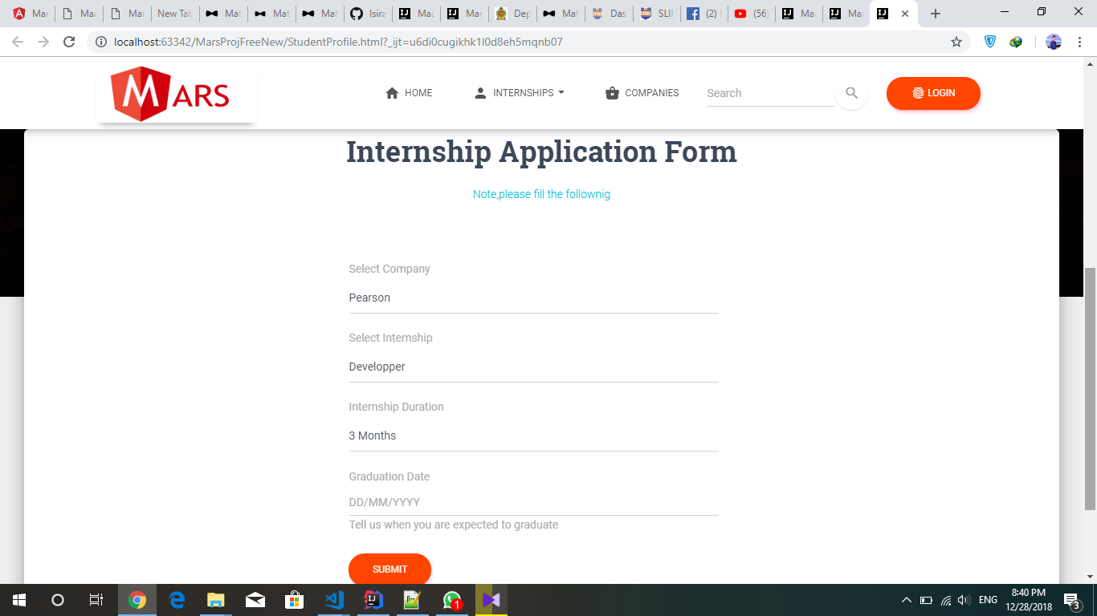

Figure 4.1.4

Applicant should fill the fields such as selected company, type of internship, internship duration and graduation date which cannot be left blank.

After the submission, details of the applicant will be saved to his/her profile and up to date related vacancies will be listed for the user once he browses for internships.

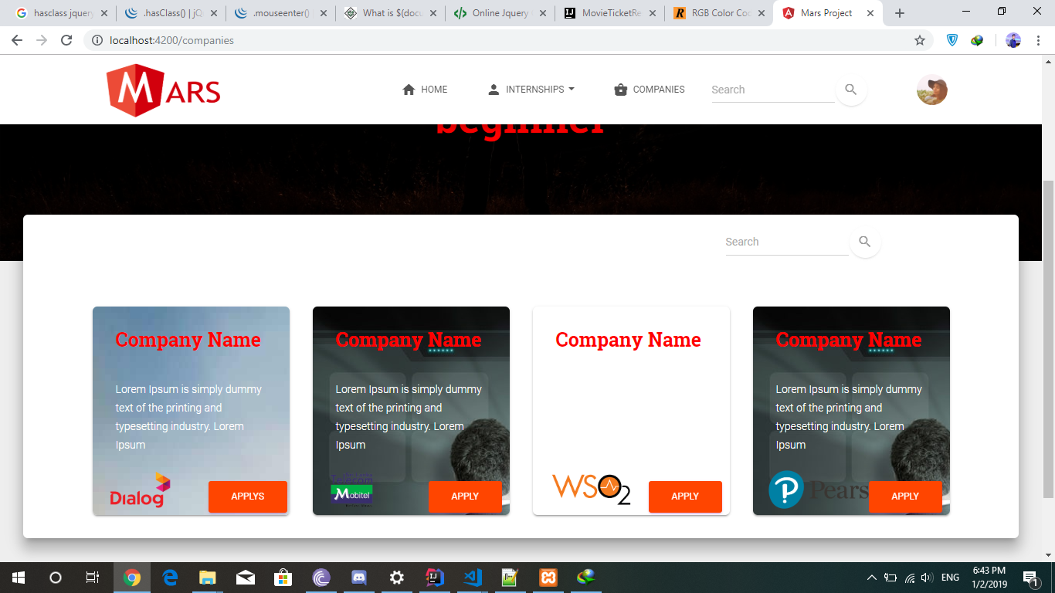

Figure 4.1.5

Above figure illustrates how it appears when the user accesses the “Companies” section in the system.

Few company names with a small description will be appeared once the user clicks on “Companies” where the particular user is benefitted with applying to any of them by clicking on the “Apply” button which is at the bottom right corner of each package.

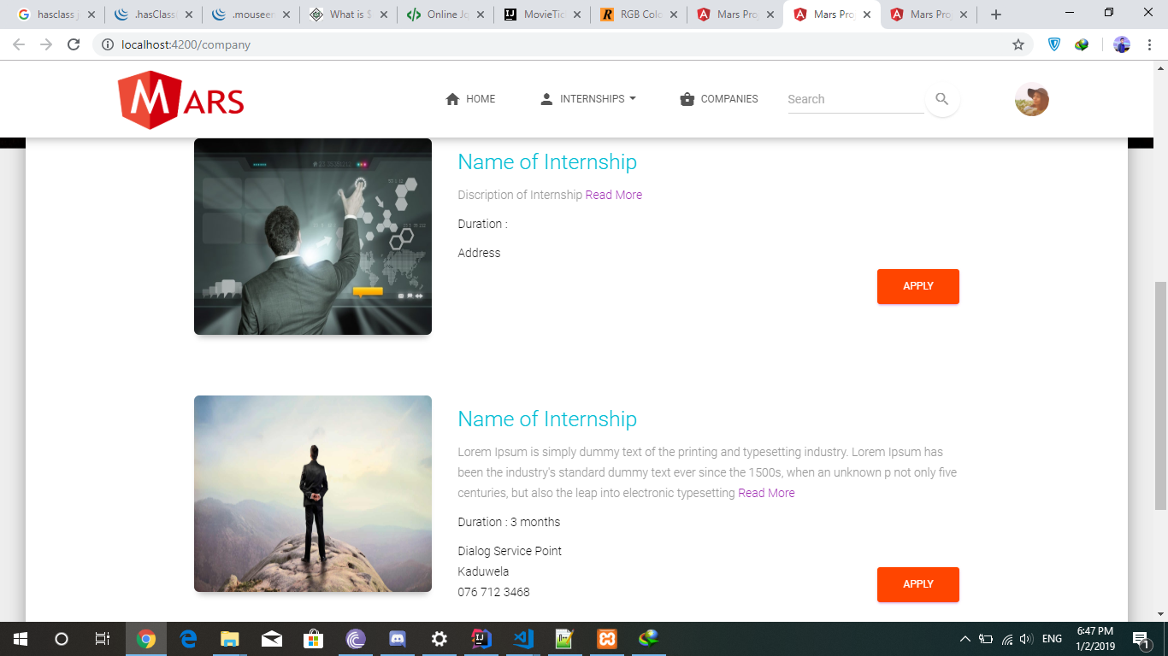

Figure 4.1.6

Once the user selects one of the companies, up to date internships will be listed down from that particular company (Figure 4.1.6).

All the details related to each internship like duration, address, contact numbers will be displayed within that thumbnail and user can apply to one of those according to their interest.

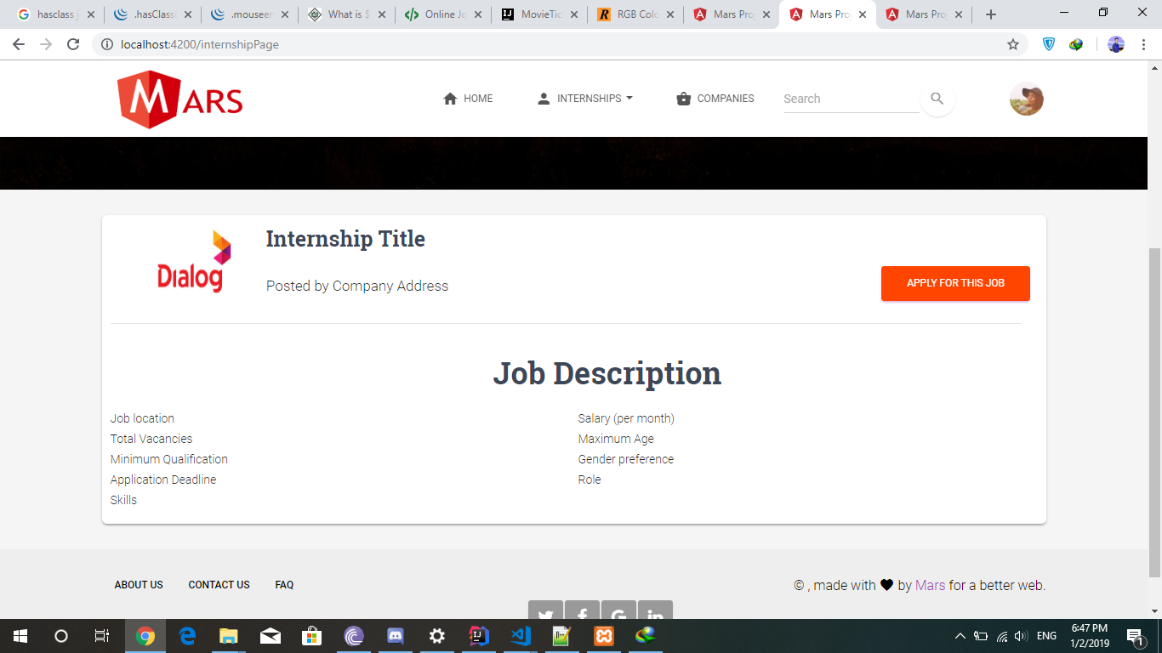

The interface template used by the developers for the above purpose

Figure 4.1.7

4.2 Hardware Requirements

Since all of the users are using the web client, they can access the system through their browsers which support HTML5, JavaScript, CSS which are features backed by modern day browsers.

Microsoft Internet Explorer (IE) v11 or later, Firefox v45 or later and Google Chrome v58 or later are preferred for a good experience.

In other browsers, performance and graphical consistency may suffer.

|  |  |
| --- | --- |
| **Hardware** | **Minimum requirements** |
| Computer | Intel or compatible Pentium class 4 processor or higher for the server to run the NodeJS Server.  Clients can browse the website via PC or mobile devices that support web browser facilities |
| Memory (RAM) | At least 4GB, preferably higher for server  Client to browse the webpage 2GB cache memory |
| Hard disk space | At least 100 GB for server  Client to browse the webpage 256MB to install the web browser on mobile phone or PC |
| Other | Network connections and Firewall to cater HTTPS requests and responses securely. |

Preferred minimum system requirements for a PC/mobile device are as follows,

4.3 System Requirements

Database of the system would be updated each time the database of SLIIT student was updated, while the communication between the web client and the database included only reading from the database.

|  |  |
| --- | --- |
| **Software** | **Minimum requirements** |
| Operating system | Windows Server 2012 R2 or above for the server.  Any OS that supports web browsers would be sufficient for Clients (users of the system) |
| IIS (Internet Information Services) | Version 7.5 or higher |
| Microsoft .Net Framework v4.6.1  (or higher | Requires the machine that IIS is running on to have the Microsoft .NET v4.6.1 (or higher) Framework installed as well as the ASP.Net 4.5 and .Net Extensibility 4.5 features enabled. |
| Database | Mongo DB 4.0.5 |
| Server & Web development | NodeJS version 11.0.2 for server  Express latest version (backend processing)  AngularJS version 6.0 (front end)  HTML5, CSS, Bootstrap for styling |

4.4. Communication requirements

The protocol that is used in communication between web client and the server is HTTPS.

The protocol that is used in communicating via emails between the client and the system is SMTP.

Server to host the NodeJS server and a domain (website address) to host the website

5. Non-functional Requirements

* Performance **-** The website consists in page windows and all the windows will prompt within two seconds of time. Also, the home screen will prompt within three seconds only if the user has entered the correct user name and password.
* Security **-** The website uses all students’ data via SLIIT student database and there is always a real time connectivity with the SLIIT database. So there are specific logins for deans, admins, students and etc. By using this specific logins, system be able to protect students’ data by leaking and handing over to another unauthorized party.
* Availability **–** The website is available on 24/7. High availability will leads the users to access the site at any time and also be able to face any exams such as aptitude tests at any time.
* Recoverability **–** Usage of several databases is leaded to high recoverability of data when it is deleted or needed to being recovered. And Usage of several data storing methods is helped to protect data and recover them.
* Interoperability **–** The system is designed in such a way that the website can work in integration with different operating systems and web browsers. And it can be changed according to the convenience of the users.
* Usability **–** The system consists of user-friendly interfaces. So any user who uses this system can easily access to anything within the system and the user does not need a high technical knowledge to access the system.
* Fault Tolerance **–** The system functionality is perfectly monitored with the developers of the system as well as they measure and manage the functionality of the system. If any bug or similar circumstance was happened, by using such fault tolerance methods it can be easily prevented.
* Environmental Requirements **–** The legal requirements (such as operations of the system) do not affect to the environment in a negative way.
* Robustness **–** The reloading time of the website is high due to failures. And the percentage of failures of the website is low as well as the probability of data corruption after a failure is low.

6. Appendix

E-R diagram

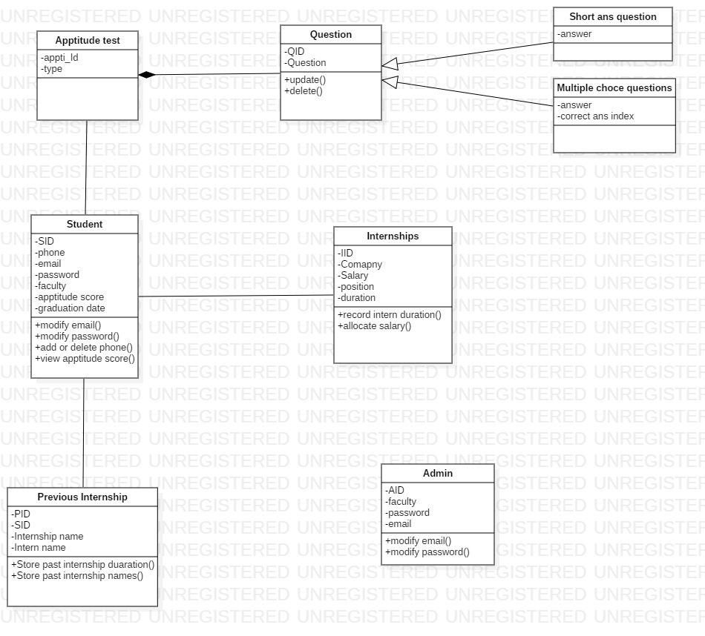Class Diagram

Use case diagram

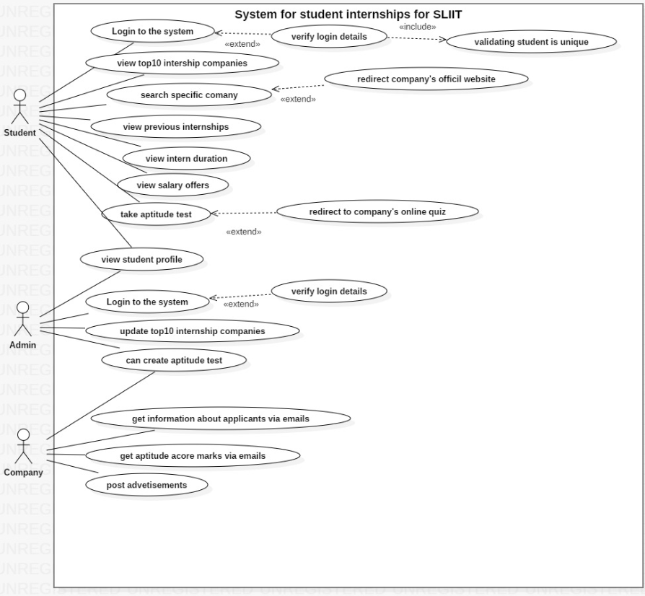

Use Case Scenarios

|  |  |
| --- | --- |
| Scenario number | 1 |
| Scenario name | Login |
| Primary actor | Student/Admin |
| Pre-condition | 1. Student should be a SLIIT registered student  2. Admin should be a dean in each faculty in SLIIT |
| Main success scenario | 1. User enters to the login page  2. User enters their user ID  3. User enters their user password  4. Clicking the sign in button  5. System verify the user credentials  6. Showing a message of successful login  7. Successfully redirect user to home page |
| Extensions | 5.A. System identify credentials are invalid  5.A.1. Showing an error message |

|  |  |
| --- | --- |
| Scenario number | 2 |
| Scenario name | View profile |
| Primary actor | Student/Admin |
| Pre-condition | 1. User should already log in to the system |
| Main success scenario | 1. User should navigate to the view profile button  2. User should able to view their profile by clicking the respective button |
| Extensions |  |

|  |  |
| --- | --- |
| Scenario number | 3 |
| Scenario name | Search internships |
| Primary actor | Student |
| Pre-condition | 1. Student should already be logged in to the system |
| Main success scenario | 1. Student should navigate to the search bar  2. Student should enter internship to the search page  3. Student can also search internships in top 10 list  4. Student click on company name  5. System redirect the student to company’s official website for further information |
| Extensions | 3.A. Display successful search result in top 10 list  3.A.2. Alternatively student can search if their choice not in top 10 list  3.A.2.A. Display successful alternative search result  3.B. Display message of search not found |

|  |  |
| --- | --- |
| Scenario number | 4 |
| Scenario name | Take aptitude test |
| Primary actor | Student |
| Pre-condition | 1. Student should already log in to the system  2. Student should navigate to specific company  3. Student selects job position |
| Main success scenario | 1. Student should navigate to the take aptitude test link button and click it  2. Student should answer the randomized test  3. Student should complete the test within given time period  4. Student should navigate to the submit button and click to proceed once all questions have been answered  5. Notify the student the quiz has been completed. |
| Extensions | 1.A. Student should redirect to the company’s aptitude test elsewhere  1.B. If the company does not have an predefined test, System prompts the student with a pop quiz  4.A. System should not display the marks students got  4.A.1. System should select students who score above pass mark  4.B.2. System should notify the selected students to the relevant companies (via email) |

|  |  |
| --- | --- |
| Scenario number | 5 |
| Scenario name | Create aptitude test |
| Primary actor | Admin |
| Pre-condition | 1. Admin should log in to the system  2. Should be a faculty dean |
| Main success scenario | 1. Admin should navigate to the aptitude section  2. Admin should select company, job title and click create quiz button and create a new quiz  3. Admin can preview previous questions  4. Admin can make changes in questions  5. Admin should click on save changes button |
| Extensions | 2.A. Admin can update new questions  2.A.1. Successfully updated questions  2.B. Admin can delete old questions  2.B.1. Successfully deleted questions |

|  |  |
| --- | --- |
| Scenario number | 6 |
| Scenario name | Edit top 10 list |
| Primary actor | Admin |
| Pre-condition | 1. Admin should already log in to the system |
| Main success scenario | 1. Admin should navigate to the internship section  2. Admin should click edit button  3. Admin can make changes in internships  4. Admin should click on save changes button |
| Extensions | 2.A. Admin can update new internships  2.A.1. System Successfully updates top 10 lsit  2.B. Admin can remove under rating internships  2.B.1. System Successfully removes top 10 list |

# Development Team

**Project Director** – Shane De Silva

**Project Manager** – Sonal Rathnayake

**Database and Server Development** – Isira Seneviratne

**Website Backend Development**

* Ganond Chathuramadu
* Nimesh Mendis
* Kulunu
* Sonal Rathnayake
* Isira Seneviratne
* Keshan Maduranga
* Gangesh
* Hareendran Sheeran

**Website Frontend** **Development**

* Ganond Chathuramadu
* Harin

**Documentation & Agile development Manager** – Ishara Pasan

**Documentation team**

* Manoj Saranga
* Vindya Wijesinghe
* Praveen Vidyaratne
* Chamod Peiris
* Sonal Rathnayake
* Nimesh Mendis
* Ishara Pasan